# Aim: Draw the Bar chart, Histogram, stacked bar chart using plotly, matplotlib and seaborn libraries in python on random dataset.

**IDE:** Excel, Tableau, Spyder IDE

# Theory:

**Bar Chart**

# Bar charts in Excel - the basics

A bar graph, or bar chart is a graph that displays different categories of data with rectangular bars, where the lengths of the bars are proportional to the size of the data category they represent. Bar graphs can be plotted vertically or horizontally. A vertical bar graph in Excel is a separate chart type, known as a column bar chart.

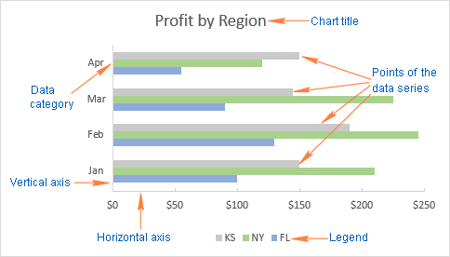To make the rest of this bar chart tutorial easier to comprehend and to ensure that we are always on the same page, let's define the basic elements of an Excel bar graph. The following image shows the standard 2-D clustered bar chart with 3 data series (grey, green and blue) and 4 data categories (Jan - Apr).

# How to make a bar graph in Excel

Making a bar graph in Excel is as easy as it could possibly be. Just select the data you want to plot in your chart, go to the Insert tab > Charts group on the ribbon, and click the bar chart type you want to insert.

In this, example, we are creating the standard 2-D Bar chart:

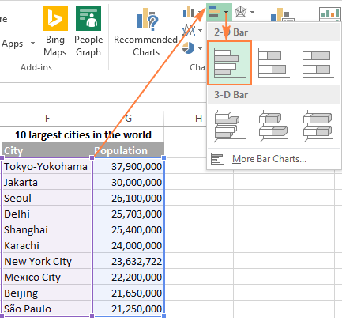

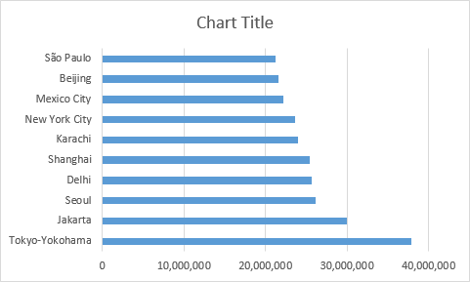The default 2-D clustered bar graph inserted in your Excel worksheet will look something like this:

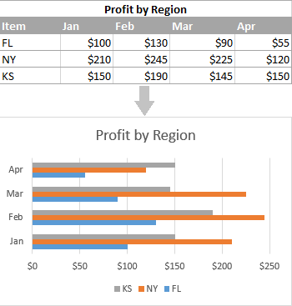The Excel bar graph above displays one data series because our source data contains just one column of numbers. If your source data has two or more columns of numerical values, your Excel bar graph will contain several data series, each shaded in a different color:

View all available bar chart types

To see all bar graph types available in Excel, click the More Column Charts... link, and choose one of the bar chart sub-types that are displayed at the top of the Insert Chart window:

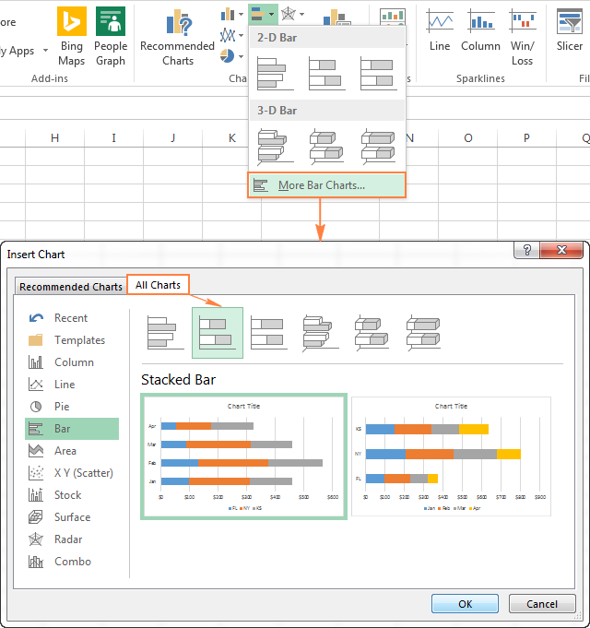

Choose the bar graph layout and style

If you are not fully satisfied with the default layout or style of the bar graph inserted in your Excel sheet, select it to activate the Chart Tools tabs on the ribbon. After that, go to Design tab and do any of the following:

* Try different bar graph layouts by clicking the Quick Layout button in the Chart Layouts group, or
* 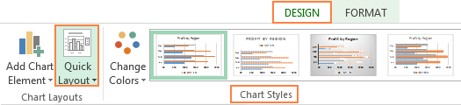Experiment with various bar chart styles in the Chart Styles group.

# Excel bar chart types Clustered bar charts

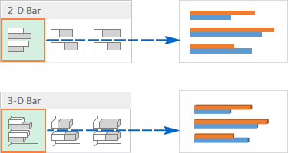A clustered bar chart in Excel (2-D or 3-D) compares values across data categories. In a clustered bar graph, the categories are typically organized along the vertical axis (Y axis), and the values along the horizontal axis (X axis). A 3-D clustered bar chart does not display a 3rd axis, but rather presents horizontal rectangles in 3-D format.

# Stacked bar charts

A stacked bar graph in Excel shows the proportion of individual items to the whole. As well as clustered bar graphs, a stacked bar chart can be drawn in 2-D and 3-D format:

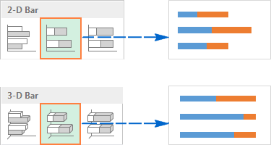

# 100% stacked bar charts

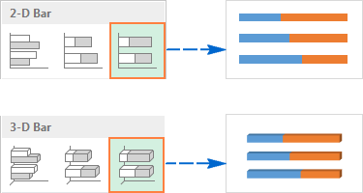This type of bar graphs is similar to the above type, but it displays the percentage that each value contributes to a total in each data category.

# Cylinder, cone and pyramid charts

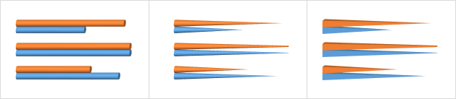Like standard rectangular Excel bar charts, cone, cylinder and pyramid graphs are available in clustered, stacked, and 100% stacked types. The only difference is that these chart types represent data series in the form or cylinder, cone, and pyramid shapes instead of bars.

In Excel 2010 and earlier versions, you can create a cylinder, cone, or pyramid chart in the usual way, by selecting the corresponding graph type in the Charts group on the Insert tab.

# Histogram Chart

**What is a histogram?**

A histogram is a chart that shows the frequency distribution of a set of values. The frequency distribution of these values are arranged into specified ranges known as bins.

Examples of using a histogram include grouping performance scores into ranges, grouping values into ranges of years, or survey responses grouped into age brackets. A histogram is a type of data visualization.

# How to create a histogram in Excel using Analysis ToolPak

The Analysis ToolPak is a Microsoft Excel data analysis add-in, available in all modern versions of Excel beginning with Excel 2007. However, this add-in is not loaded automatically on Excel start, so you would need to load it first.

# Load the Analysis ToolPak add-in

To add the Data Analysis add-in to your Excel, perform the following steps:

* In Excel 2010 - 365, click File > Options. In Excel 2007, click the Microsoft Office button, and then click Excel Options.
* 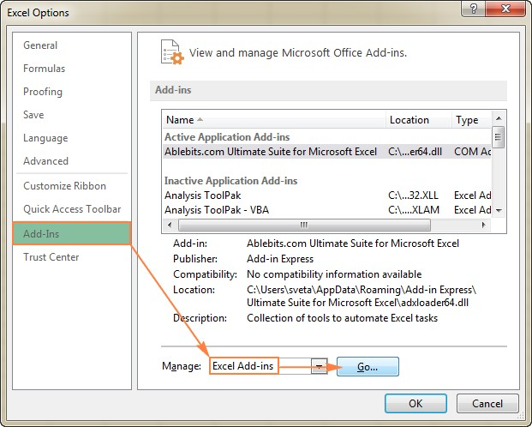In the Excel Options dialog, click Add-Ins on the left sidebar, select Excel Add-ins in the Manage box, and click the Go button.

In the Add-Ins dialog box, check the Analysis ToolPak box, and click OK to close the dialog.

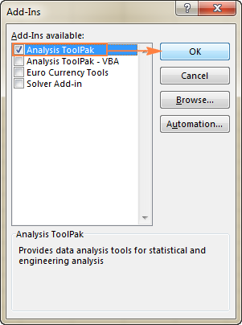If Excel shows a message that the Analysis ToolPak is not currently installed on your computer, click Yes to install it.

Now, the Analysis ToolPak is loaded in your Excel, and its command is available in the Analysis group on the Data tab.

Make a histogram using Excel's Analysis ToolPak

With the Analysis ToolPak enabled and bins specified, perform the following steps to create a histogram in your Excel sheet:

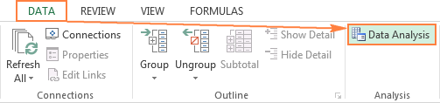On the Data tab, in the Analysis group, click the Data Analysis button.

In the Data Analysis dialog, select Histogram and click OK.

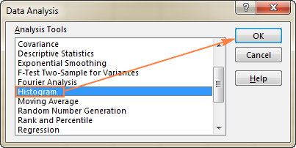

In the Histogram dialog window, do the following:

Specify the **Input range** and the **Bin range**.

To do this, you can place the cursor in the box, and then simply select the corresponding range on your worksheet using the mouse. Alternatively, you can click the *Collapse Dialog* button Collapse Dialog button , select the range on the sheet, and then click the *Collapse Dialog* button again to return to the *Histogram* dialog box.

* Select the **Output options**.

To place the histogram on the same sheet, click *Output Range*, and then enter the upper-left cell of the output table.

To paste the output table and histogram in a new sheet or a new workbook, select *New Worksheet Ply* or *New Workbook*, respectively.

Finally, choose any of the additional options:

* To present data in the output table in descending order of frequency, select the **Pareto** (sorted histogram) box.
* To include a cumulative percentage line in your Excel histogram chart, select the **Cumulative Percentage** box.
* To create an embedded histogram chart, select the **Chart Output** box.

For this example, I've configured the following options:

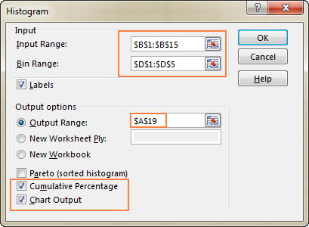

And now, click OK, and review the output table and histogram graph:

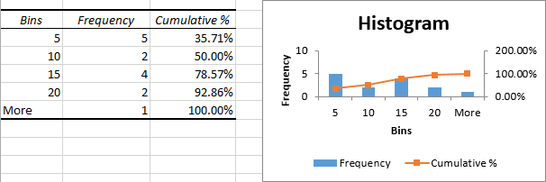

# How to make a histogram in Excel using formulas

Another way to create a histogram in Excel is using the FREQUENCY or COUNTIFS function. The biggest advantage of this approach is that you won't have to re-do your histogram with each change in the input data. Like a normal Excel chart, your histogram will **update automatically** as soon as you edit, add new or delete existing input values.

To begin with, arrange your source data in one column (column B in this example), and enter the bin numbers in another column (column D), like in the screenshot below:

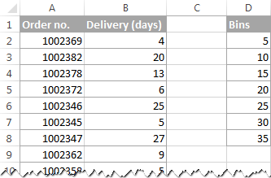

# Pre Lab Exercise:

1. How is a histogram different to a column chart?
2. How to create a histogram in Excel with the histogram chart
3. What is a stacked bar chart?

# Pre-Lab Tasks:

Perform the following tasks using Excel:

Task 1: Draw bar chart using superstore data (Order Date vs. Sales)

# Results:-

Task 2: Draw Stacked bar chart using superstore data (Order Date vs. Sales (Considered Region dimension))

# Results:-

Task 3: Draw histogram chart using superstore data

# Results:-

# In-Lab Tasks:

Perform the following tasks using Tableau:

Task 1: Draw bar chart using superstore data (Order Date vs. Sales)

# Results:-

Task 2: Draw Stacked bar chart using superstore data (Order Date vs. Sales (Considered Region dimension))

# Results:-

Task 3: Draw histogram chart using superstore data

# Result

# Post-Lab Tasks:

Perform the following tasks using Python:

**Pre-Requisites :-**

**# Import necessary libraries**

import pandas as pd **# For data manipulation and analysis**

import numpy as np **# For numerical operations**

import matplotlib.pyplot as plt **# For basic plotting**

import seaborn as sns **# For advanced data visualization**

**# Read the dataset from Excel file**

Dataset = pd.read_excel("D:/Aryan Data/Usefull Data/Semester - 4/Data Visulization and Dashboards/Lab Manual/Exp-5 Creating bar plot stacked bar and histogram/Sample - Superstore.xlsx","Orders",)

**# Convert 'Order Date' column to datetime format**

Dataset["Order Date"] = pd.to_datetime(Dataset["Order Date"])

**# Extract the quarter from 'Order Date' and create a new column 'Quarter'**

Dataset["Quarter"] = Dataset["Order Date"].dt.quarter

Task 1: Draw bar chart using superstore data (Order Date vs. Sales)

**Code:-**

plt.figure(figsize=(16, 8))

sns.barplot(x="Year", y="Sales", data=Dataset, estimator=sum)

plt.xlabel("Years")

plt.ylabel("Total Sales")

plt.title("Order Date vs Sales (Years)")

plt.show()

# Results:-

Task 2: Draw Stacked bar chart using superstore data (Order Date vs. Sales (Considered Region dimension))

**Code :-**

New_Dataset = Dataset.groupby(["Year", "Region"])["Sales"].sum().reset_index()

Central_Sales = []

East_Sales = []

South_Sales = []

West_Sales = []

for i in range(0, 16, 4):

Central_Sales.append(New_Dataset.iloc[i, 2])

for i in range(1, 16, 4):

East_Sales.append(New_Dataset.iloc[i, 2])

for i in range(2, 16, 4):

South_Sales.append(New_Dataset.iloc[i, 2])

for i in range(3, 16, 4):

West_Sales.append(New_Dataset.iloc[i, 2])

Year = [2014, 2015, 2016, 2017]

Central_Sales = np.array(Central_Sales)

East_Sales = np.array(East_Sales)

South_Sales = np.array(South_Sales)

West_Sales = np.array(West_Sales)

plt.figure(figsize=(16, 8))

plt.bar(Year, Central_Sales, color="red")

plt.bar(Year, East_Sales, bottom=Central_Sales, color="blue")

plt.bar(Year, South_Sales, bottom=Central_Sales + East_Sales, color="green")

plt.bar(Year, West_Sales, bottom=Central_Sales + East_Sales + South_Sales, color="orange")

plt.legend(["Central", "East", "South", "West"])

plt.show()

# Results:-

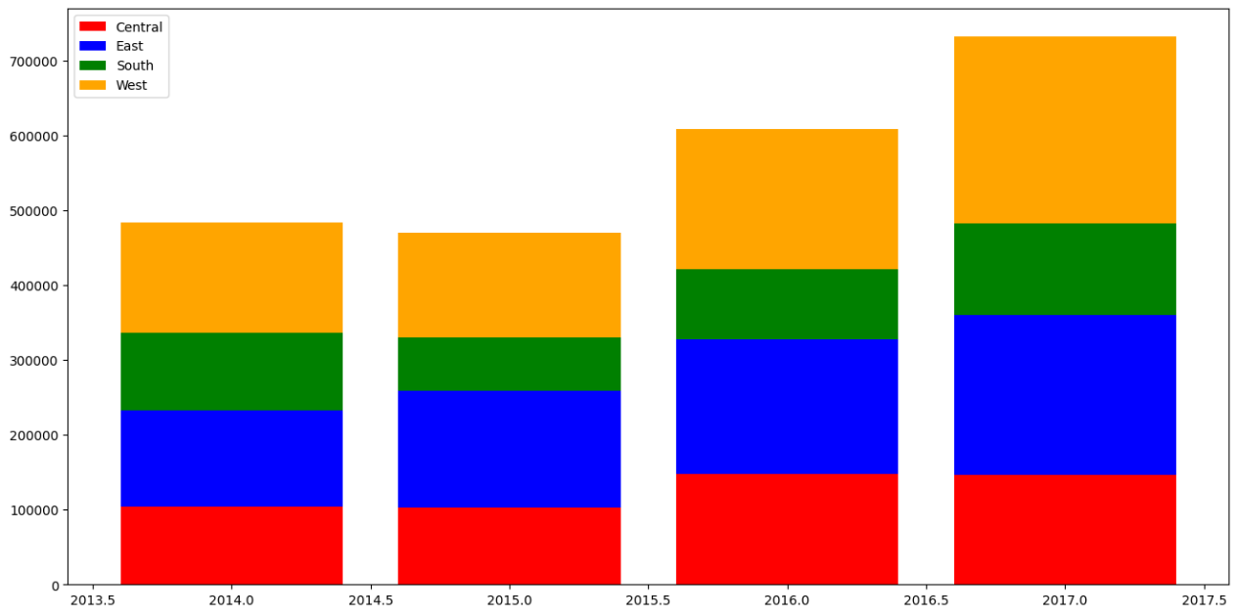

Task 3: Draw histogram chart using superstore data

**Code:-**

plt.figure(figsize=(10, 6)) # Adjusted from (12, 6)

sns.histplot( Dataset["Quantity"], bins=[1, 2, 3, 4, 5, 6, 7, 8, 9, 10, 11, 12, 13, 14], # Define bin edges

kde=False, color="green", linewidth=0.5,edgecolor="black",)

plt.title("Histogram of Quantity in Superstore Data")

plt.xlabel("Quantity")

plt.ylabel("Count")

plt.xticks(ticks=[1, 2, 3, 4, 5, 6, 7, 8, 9, 10, 11, 12, 13, 14])

plt.yticks(ticks=[0, 1000, 2000, 3000])

plt.tight_layout()

plt.show()

# Results:-

Reference Link: <https://help.tableau.com/current/pro/desktop/en-us/buildexamples_bar.htm> <https://help.tableau.com/current/pro/desktop/en-us/qs_combo_charts.htm> <https://help.tableau.com/current/pro/desktop/en-us/buildexamples_histogram.htm>

# Observation and Result Analysis:

Write the final observation and process corresponding to each task

**1. _ _**

**_ _**

**_ _**

**2. _ _**

**_ _**

**_ _**

**3. _ _**

**_ _**

**_ _**

# Post Lab Exercise:

**Python Implementation**

**Reference Link:** [**https://aman2457.medium.com/superstore-sales-data-analysis-and-visualization-**](https://aman2457.medium.com/superstore-sales-data-analysis-and-visualization-using-python-and-plotly-part1-fc1f71a7289a)[**using-python-and-plotly-part1-fc1f71a7289a**](https://aman2457.medium.com/superstore-sales-data-analysis-and-visualization-using-python-and-plotly-part1-fc1f71a7289a)

[**https://www.kaggle.com/code/alaasedeeq/superstore-data-analysis-with-plotly**](https://www.kaggle.com/code/alaasedeeq/superstore-data-analysis-with-plotly)[**https://www.kaggle.com/code/zhukovoleksiy/superstore-dataset-complete-analysis-plotly**](https://www.kaggle.com/code/zhukovoleksiy/superstore-dataset-complete-analysis-plotly)